**Case Study #1 - Danny's Diner**

**This is the solution for 1st case study of the challenge**

**CREATE** **SCHEMA** dannys_diner;

**SET** search_path = dannys_diner;

**CREATE** **TABLE** sales (

"customer_id" VARCHAR(1),

"order_date" DATE,

"product_id" INTEGER

);

**INSERT** **INTO** sales

("customer_id", "order_date", "product_id")

**VALUES**

('A', '2021-01-01', '1'),

('A', '2021-01-01', '2'),

('A', '2021-01-07', '2'),

('A', '2021-01-10', '3'),

('A', '2021-01-11', '3'),

('A', '2021-01-11', '3'),

('B', '2021-01-01', '2'),

('B', '2021-01-02', '2'),

('B', '2021-01-04', '1'),

('B', '2021-01-11', '1'),

('B', '2021-01-16', '3'),

('B', '2021-02-01', '3'),

('C', '2021-01-01', '3'),

('C', '2021-01-01', '3'),

('C', '2021-01-07', '3');

**CREATE** **TABLE** menu (

"product_id" INTEGER,

"product_name" VARCHAR(5),

"price" INTEGER

);

**INSERT** **INTO** menu

("product_id", "product_name", "price")

**VALUES**

('1', 'sushi', '10'),

('2', 'curry', '15'),

('3', 'ramen', '12');

**CREATE** **TABLE** members (

"customer_id" VARCHAR(1),

"join_date" DATE

);

**INSERT** **INTO** members

("customer_id", "join_date")

**VALUES**

('A', '2021-01-07'),

('B', '2021-01-09');

**Input Tables:**

**Sales table**

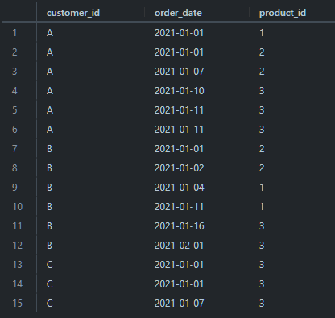

**Menu Table Members Table**

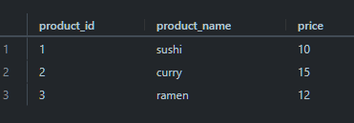 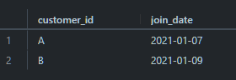

1. What is the total amount each customer spent at the restaurant?

WITH CustomerSpending AS (

SELECT s.customer_id, SUM(m.price) AS amount_spent

FROM sales s

INNER JOIN menu m ON s.product_id = m.product_id

GROUP BY s.customer_id )

SELECT * FROM CustomerSpending

ORDER BY amount_spent DESC;

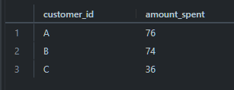

1. How many days has each customer visited the restaurant?

WITH CTE AS (

SELECT customer_id, EXTRACT(DAY FROM order_date) AS day_visited

FROM sales )

SELECT customer_id, COUNT(DISTINCT day_visited) AS total_days_visited

FROM CTE

GROUP BY customer_id

ORDER BY total_days_visited DESC;

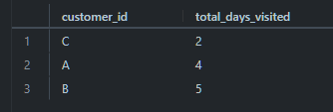

1. What was the first item from the menu purchased by each customer?

WITH FirstPurchase AS (

SELECT customer_id,

MIN(order_date) AS first_order_date FROM sales

GROUP BY customer_id )

SELECT F.customer_id, M.product_name

FROM FirstPurchase F

JOIN sales S ON F.customer_id = S.customer_id AND F.first_order_date = S.order_date

JOIN menu M ON S.product_id = M.product_id;

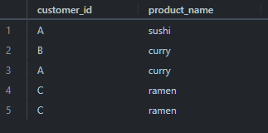

1. What is the most purchased item on the menu and how many times was it purchased by all customers?

WITH CTE AS (

SELECT customer_id, product_id, COUNT(*) AS total_purchases

FROM sales

GROUP BY customer_id, product_id )

SELECT M.product_name, CTE.total_purchases

FROM CTE

INNER JOIN menu M ON M.product_id = CTE.product_id

ORDER BY CTE.total_purchases DESC

LIMIT 1;



1. Which item was the most popular for each customer?

WITH CTE AS (

SELECT customer_id, product_id, COUNT(*) AS total

FROM sales

GROUP BY customer_id, product_id )

SELECT C.customer_id, M.product_name

FROM (

SELECT customer_id, product_id, total,

RANK() OVER (PARTITION BY customer_id ORDER BY total DESC) AS rnk

FROM CTE

) AS C

JOIN menu M ON M.product_id = C.product_id

WHERE rnk = 1;

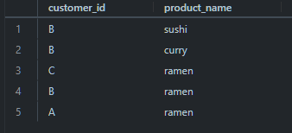

1. Which item was purchased first by the customer after they became a member?

WITH RANK AS

(SELECT S.CUSTOMER_ID,

M.PRODUCT_NAME,

DENSE_RANK() OVER (PARTITION BY S.CUSTOMER_ID

ORDER BY S.ORDER_DATE) AS RNK

FROM SALES S

JOIN MENU M ON M.PRODUCT_ID = S.PRODUCT_ID

JOIN MEMBERS MEM ON MEM.CUSTOMER_ID = S.CUSTOMER_ID

WHERE S.ORDER_DATE >= MEM.JOIN_DATE )

SELECT R.CUSTOMER_ID, R.PRODUCT_NAME

FROM RANK R

WHERE RNK = 1;

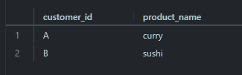

1. Which item was purchased just before the customer became a member?

WITH RANK AS

(SELECT S.CUSTOMER_ID,

M.PRODUCT_NAME,

DENSE_RANK() OVER (PARTITION BY S.CUSTOMER_ID

ORDER BY S.ORDER_DATE) AS RNK

FROM SALES S

JOIN MENU M ON M.PRODUCT_ID = S.PRODUCT_ID

JOIN MEMBERS MEM ON MEM.CUSTOMER_ID = S.CUSTOMER_ID

WHERE S.ORDER_DATE < MEM.JOIN_DATE )

SELECT R.CUSTOMER_ID,R.PRODUCT_NAME

FROM RANK R

WHERE RNK = 1;

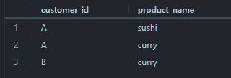

1. What is the total items and amount spent for each member before they became a member?

SELECT S.CUSTOMER_ID,

COUNT(*) AS TOTAL_ITEMS,

SUM(M.PRICE) AS AMOUNT_SPENT

FROM SALES S

JOIN MEMBERS MS ON MS.CUSTOMER_ID = S.CUSTOMER_ID

AND S.ORDER_DATE < MS.JOIN_DATE

JOIN MENU M ON M.PRODUCT_ID = S.PRODUCT_ID

GROUP BY 1;

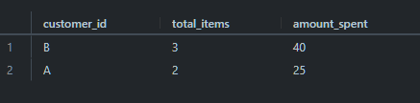

1. **If each $1 spent equates to 10 points and sushi has a 2x points multiplier - how many points would each customer have?**

with pointscte as (

select *, case when product_id = 1 then 20*price

                else 10*price end as points

                from menu)

select s.customer_id , sum(pc.points) as total_points  from pointscte pc

right join sales s

on s.product_id = pc.product_id

group by  s.customer_id

order by total_points desc;

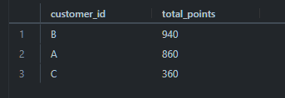

1. **In the first week after a customer joins the program (including their join date) they earn 2x points on all items, not just sushi - how many points do customer A and B have at the end of January?**

**SELECT**

    s.customer_id,

    SUM(

        CASE

            WHEN (DATE_TRUNC('day', s.order_date) - DATE_TRUNC('day', me.join_date) BETWEEN '0 days' AND '7 days') OR (m.product_id = 1) THEN m.price * 20

            ELSE m.price * 10

        END

    ) AS Points

FROM members AS me

INNER JOIN sales AS s ON s.customer_id = me.customer_id

INNER JOIN menu AS m ON m.product_id = s.product_id

WHERE s.order_date >= me.join_date AND s.order_date <= '2021-01-31'

GROUP BY s.customer_id

order by 1;

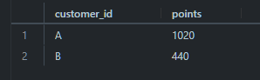

**Note : you can use date_trunc, extract and date_part functions also**

## **Bonus Questions**

### Join All The Things

The following questions are related creating basic data tables that Danny and his team can use to quickly derive insights without needing to join the underlying tables using SQL.

Recreate the following table output using the available data:

CREATE TABLE customer_orders AS

SELECT

s.customer_id,

s.order_date,

m.product_name,

m.price,

CASE WHEN mem.customer_id IS NOT NULL THEN 'Y' ELSE 'N' END AS member

FROM

sales s

JOIN

menu m ON s.product_id = m.product_id

LEFT JOIN

members mem ON s.customer_id = mem.customer_id AND s.order_date >= mem.join_date;

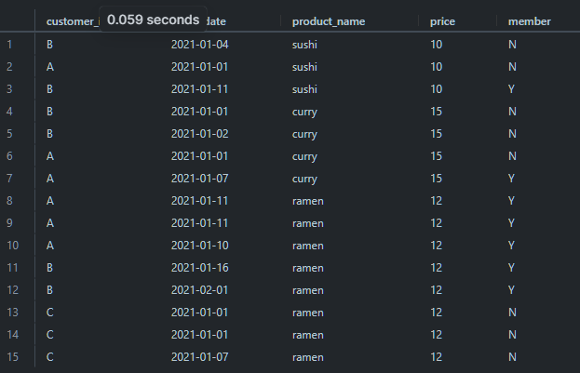

### **Rank All The Things**

Danny also requires further information about the ranking of customer products, but he purposely does not need the ranking for non-member purchases so he expects null ranking values for the records when customers are not yet part of the loyalty program.

**CREATE TABLE customer_product_ranking AS**

**WITH RankedProducts AS (**

**SELECT s.customer_id, s.order_date, m.product_name,**

**m.price, CASE WHEN mem.customer_id IS NOT NULL THEN 'Y' ELSE 'N'**

**END AS member,**

**ROW_NUMBER() OVER (PARTITION BY s.customer_id, mem.customer_id ORDER BY s.order_date) AS ranking**

**FROM**

**sales s**

**JOIN**

**menu m ON s.product_id = m.product_id**

**LEFT JOIN**

**members mem ON s.customer_id = mem.customer_id AND s.order_date >= mem.join_date**

**)**

**SELECT customer_id, order_date, product_name, price, member,**

**CASE WHEN member = 'Y' THEN ranking ELSE NULL**

**END AS ranking**

**FROM**

**RankedProducts;**

